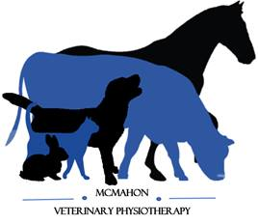
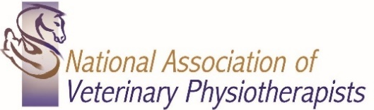
McMahon Veterinary Physiotherapy

Danielle McMahon
BSc (Hons), PgD (Vet Phys), MNAVP, MAHPR
Veterinary Physiotherapist
Veterinary Authorisation and Client Registration Form
(Please complete Client and Animal details and then pass this form to your Veterinary Surgeon, kindly requesting the Vets section is completed and either returned to the owner or myself)

Clients Details
Name: Age:
Species (Canine/Feline/Equine/Other):
Breed:
Sex:
Neutered: Y/ N
Date of Birth:
Insurance Company: Policy Number:
Date of most recent Vaccination:
Name:
Address:
Postcode:
Home Telephone: Mobile:
Date Email:
Animals Details
Veterinary Practice
Veterinary Surgeon:
Veterinary Practice Address:
Telephone and Email:
Summary of Relevant Medical History and Background:

Please send medical history along with his form
Medication:
Veterinary Surgeon Declaration: In my opinion, the above-named animal is in a suitable state of health to undergo Physiotherapy
I understand that by giving consent, I am not responsible for any (type) treatment given and the provision of professional indemnity insurance for this is the responsibility of McMahon Veterinary Physiotherapy
Name Printed: Signed: Date:
Vet Report Required YES ☐ NO ☐

Danielle McMahon - Veterinary Physiotherapist
07545296642 - mcmahonvetphysio@gmail.com – www.mcmahonvetphysio.co.uk

